Investing for Success

Under this agreement for 2022
Abergowrie State School will receive
$5633*

This funding will be used to
- Increase the percentage of students achieving ‘B’ or above for English
- .Continue to use, and align P-10 Literacy Continuum to monitor students’ progress, goals, and achievements in literacy.
- Continue to develop and implement Indivudal Student Inquiry Cycles through the alighnment of student goals, iteracy Continuum markers, and 5Q4 Model.

Our initiatives include
- Implementation of Quality Teaching and Learning Framework underpinned by the research of Sharratt and Fullan, to develop teachers professional knowledge and practice to develop assessment Literate Learners achieving “C” and above in English.
- Providing support for Individualised Inquiry Cycles with an explicit focus on utilising the literacy continuum as a guide for student development.
- Building teacher and teacher aide knowledge and understanding of curriculum demands, including SDK and APP planning and procedures, through planning days and attending professional learning/ site visits as available.

Our school will improve student outcomes by
Purchasing teacher release time for continues monitoring and planning of individualised inquiry cycles and learning. | Teachers to be given 1 day per term to work together on literacy continuum and IICs. | $3,200
Release Teacher Aide to attend workshops on AAP and SDK planning and approaches | T/A to attend with Principal at SDK professional learning days. | $400
Purchase of STL&N for Literacy Testing | STLN attends 1 day per term for literacy testing, using Literacy Continuum to continue the support of Individualised Learning. | $1,600

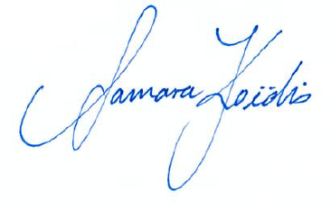
Samara Koïdis  Principal  Abergowrie State School | Michael De’Ath  Director-General  Department of Education

